For Immediate Release:

Closing on $38M in Financing for Construction of 86 New Affordable Homes in Washington, DC.
The NHP Foundation, The Warrenton Group, and The Washington Metropolitan Community Development Corporation Partner in New Residential Development

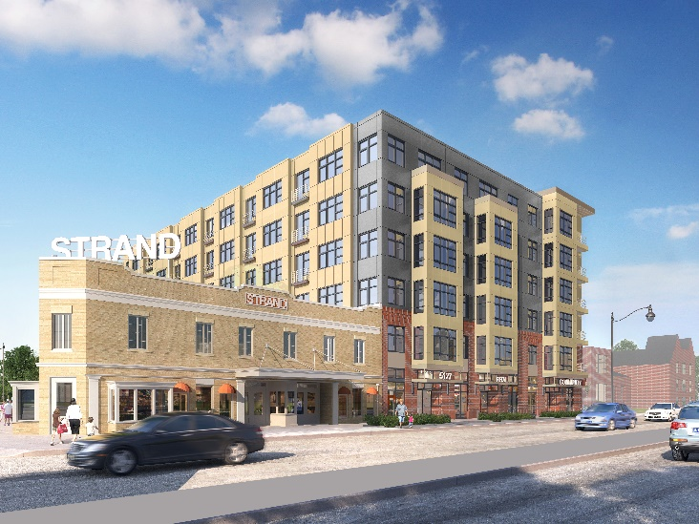
Washington, DC August 5, 2019 The NHP Foundation (NHPF), The Warrenton Group (TWG) and the Washington Metropolitan CDC (WMCDC) and financing partners - Enterprise Community Partners, Citibank, Jones Lang Lasalle, the District of Columbia Office of the Deputy Mayor for Planning and Economic Development (DMPED), the DC Housing Authority (DCHA), and the DC Housing Finance Agency (DCHFA) - closed the financing for the construction of the Strand Residences, an affordable housing development with 86 one-and two-bedroom affordable apartments in the Deanwood neighborhood of Washington, D.C.

DMPED invested $15.6M of financing from the District’s New Communities Initiative, DCHFA allocated $19.5M of tax-exempt bonds to support the project, and DCHA contributed operating subsidies for 28 units through its Local Rent Supplement Program (LRSP). As well, the tax-exempt bond allocation provided an allocation of 4% Low-Income Housing Tax Credits that helped attract a $12.3M equity investment from Enterprise Community Partners.

In addition to the 86 units, the Residences will feature a large multi-purpose room, exercise room and on-site resident services provided by NHPF’s affiliate, Operation Pathways. The first floor includes retail space for a neighborhood non-profit and a community-based retailer.

The Residences is next to the Strand Theater, a storied local landmark that the Development Team plans to convert into a new restaurant in 2020.

"Through thoughtful investment and sheer can-do attitude, our partnership is pleased to deliver on its promise to the community to provide new high-quality, affordable housing ,” said NHPF CEO and President Richard Burns. “This dynamic new development will bring permanently affordable rental units as well as community and retail space to the emerging Deanwood neighborhood. I congratulate our partners on this milestone and look forward to seeing the new building being constructed.”

“TWG and the WMCDC have been working on this project for over twelve years. TWG’s company slogan ‘Your Neighborhood, Our Commitment’ was put to the test on this project. Thankfully, the Mayor and the City Council stuck with us as we assembled this project,” said TWG President Warren Williams.

“We started dreaming and planning for this project more than 12 years ago and we’re pleased to hit this milestone,” said Pastor Stephen Young of WMCDC. “I look forward to more great things to come in Deanwood.”

PGN Architects is the architect of record, WCS Construction is the general contractor, and WCS Property Management will be the property manager. The Development Team is committed to spending at least 35% of the project’s funds on products and services provided by Certified Business Enterprises. WCS Construction is committed to meeting the District’s First Source hiring requirements.

The Residences will be constructed on an assemblage of underutilized land. No residences were displaced for this project and a local restaurant will be relocated into a new facility to ensure it can continue to operate in the neighborhood. The land assemblage was accepted into DC’s Voluntary Clean-Up program to ensure proper remediation of the brownfield that prevented its redevelopment for decades.

Once complete, the Residences will include 71 one-bedroom apartments and 15 two-bedroom units. The 28 LRSP units will be rented to residents who earn less than 30% AMI and will be reserved for residents relocating from the nearby Lincoln Heights and Richardson Dwellings properties.

“Mayor Bowser is committed to making investments that serve our residents and neighborhoods, and the Strand is the housing and amenities that longtime Deanwood residents deserve,” said Interim Deputy Mayor for Planning and Economic Development John Falcicchio. “We look forward to watching this project go up and getting DC residents moved into new high-quality, affordable homes.” Construction is expected to complete in January 2021.

A community celebration of the Residences’ groundbreaking is planned for August 28. Details will follow.

###
About The NHP Foundation
Headquartered in New York City with offices in Washington, DC, and Chicago, IL, The NHP Foundation (NHPF) is celebrating its 30th year as a publicly supported 501(c)(3) not-for- profit real estate corporation. NHPF is dedicated to preserving and creating sustainable, service-enriched multifamily housing that is both affordable to low- and moderate-income families and seniors, and beneficial to their communities. NHPF also provides a robust resident services program to nearly 18,000 community residents. Through partnerships with major financial institutions, the public sector, faith-based initiatives, and other not-for-profit organizations, NHPF has 52 properties in 15 states and the District of Columbia.

About The Warrenton Group
Since its inception in 1997, The Warrenton Group is an innovator in developing quality mixed-income housing and market-use developments, while creating substantial value for the people and the neighborhoods in which it works. TWG is a full-service development firm that works from conception to completion. It handles development, investment, construction and management with creativity that leads the industry. TWG is responsible for more than $1 billion in development, construction and investment, and has acquired, built or preserved more than 3,000 high-quality residential units and 300,000+ sf of commercial space throughout the DC metropolitan region.

About Washington Metropolitan CDC
The Washington Metropolitan Community Development Corporation is a community-based, non-profit economic development corporation working primarily in Washington, DC’s Deanwood neighborhood. Through its systematic and sustainable community development efforts, it aims to help low-income people realize their dreams of living in a vibrant, affordable community.

